Project Proposal on

**Humanitarian Response Tracking System**

**Biju Ale**

Softwarica ID: 160026

NCC ID: 0016399

Batch No.: 17A

bijuale@hotmail.com

Softwarica College of IT & E-Commerce

July 24, 2016

Table of Contents

Chapter 1 3

Introduction 3

1.1 List of main features 3

1.2 Aims 4

1.3 Objectives 4

1.4 Development Methods 4

Chapter 2 5

2.1 Work Breakdown Structure (WBS) 5

2.2 Time Estimate 5

2.3 Schedule 5

2.4 Conclusion 6

Bibliography 7

# Chapter 1

## Introduction

The onset of major disaster or crisis in a country immediately triggers a collaborative & coordinated humanitarian response from international communities. The recent example being the April 2015 Nepal earthquake response by, among myriad of agencies, Save The Children, Dan Church Aid, DFID, GIZ, IOM etcetera, which was coordinated by the UN OCHA.

As part of the early response, efforts of rescue, relief & aid distributions, and infrastructure support are paramount priority for the agencies to save the victims’ lives & support them with relief & resilience.

I propose to develop the ‘Humanitarian Response Tracking System’ for such agencies engaging in rapid humanitarian intervention. The system will support the agency to track their activities, including the beneficiary information, aid distribution counts, based on locations & technical clusters (WASH, Logistics, Food, Shelter etc.). This will also help them with monitoring & evaluation as well as help them to review their logical framework for target/results analysis.

The need for the system was felt by me personal experience, during my visit & research to one of the leading humanitarian organizations responding to the Nepal Earthquake. There was no in-house robust system to track their response. Instead, they relied on 3W/4W analysis of OCHA’s cluster reports, which all agencies were required to fill.[1] All the data were locked into massive spreadsheets.[2] & any kind of analysis was extremely difficult & time consuming. All this will be taken into account by my system.

I have planned to base my system entirely on Microsoft Access 2016, part of the office suite. It is a DBMS that combines Jet Database engine with a GUI & software development tools. Both the front end & back end can be developed using Access. And it stores all the queries, tables, forms, controls, macros, & the data in a single database file. It is also supported by VBA, an event driven programming language to define the behaviors & properties of controls & objects as per changing user inputs. (Products.office.com, 2016)

### List of main features

* User management
  + Add new staff to staff domain.
  + Modify (update/delete staff details) staff domain.
  + Register a staff as the system user.
  + Search staffs filtered by cluster department, registration status, user type.
  + Restrict usage from within staff domain.
  + Remove a registered user.
  + Modify (update/edit) user login credentials.
  + Validations on all forms (user already exists, username-password match, data type, null)
* Add & modify targets/indicators for each cluster type.
* Add activity details (cluster type, activity type, beneficiary count, relief item distribution count, location, implementing partner, vulnerable group information.)
* Modify activity details (Update/edit/delete).
* Search activities based filtration by on cluster type, implementing partner, location.
* Generate report based on filtration by implementing partner, location, activity type, cluster type, vulnerable groups.
* Generate report of overview of total beneficiaries in particular location, particular, cluster type, & vulnerable groups.
* Generate progress report based on targets & current achievement ratios.
* Export to HTML, pdf.

### Aims

* To build desktop application for humanitarian agency responding to disaster or crisis, so that they can track their response.
* To aid the agency in monitoring & evaluation of their activities including progress review.

### Objectives

* To provide authentication & security via user-type based login system.
* To allow the agency to set & modify targets/indicators for each clusters.
* To provide filtration based search facility on relevant forms.
* To provide both overview & individual level activity & beneficiary details.
* To allow generation of reports for progress review.
* To aid the end-user in export & backup of file.

### Development Methods

I have chosen Water-fall model as my system development methodology My system, which is an UDA (User Development Application), does not require project, budget, & people management, & other detailed treatments expected to be done in other methodologies. Based on my research & field experience, water-fall model will be sufficient to rapidly develop an efficient & maintainable system as proposed.

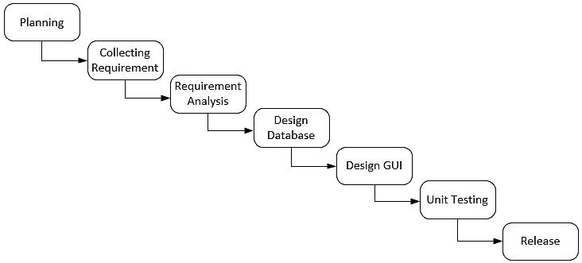

Figure 1: Waterfall model for the proposed project

# Chapter 2

### 2.1 Work Breakdown Structure (WBS)

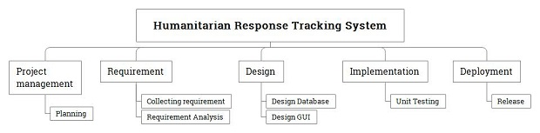

Figure : WBS Chart

### 2.2 Time Estimate

|  |  |
| --- | --- |
| **Activity** | **Estimate (days)** |
| Planning | 5 |
| Collecting requirement | 5 |
| Requirement Analysis | 5 |
| Design Database | 7 |
| Design GUI | 8 |
| Unit Testing | 5 |
| Release | 5 |
| **Total:** | **40** |

Table : Time Estimate

### 2.3 Schedule

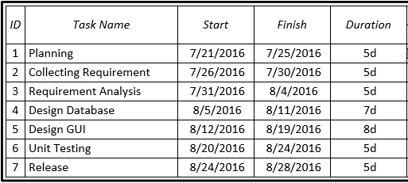

Figure : Gantt Chart 1 of 2

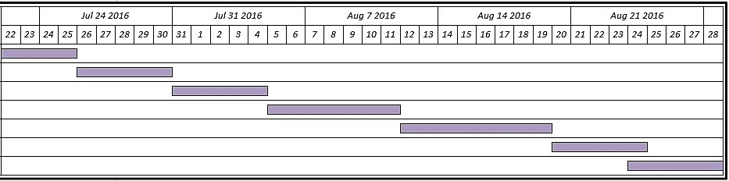

Figure : Gantt Chart 2 of 2

### 2.4 Conclusion

I have proposed to developed the Humanitarian Response Tracking System, for international humanitarian agency engaged responding to disasters & crisis in a country.

The aim of the application is to aid the agency in monitoring & evaluation of their activities including progress review. Using the waterfall model, which will be sufficient for this system, I plan to analyze, design, test, & release the system. Features would include, a user management sub-system & records of activities & beneficiary information with filtrations & reporting facilities based on various parameters. The entire system will be released as an Access database file, which will include both the front end & back end.

I have sectioned forty days starting from the submission of this proposal for my developing the system in its entirety. Based on my research & field experience of the recent Nepal earthquake & how international community operate, I hope that my system will greatly benefit agencies who are committed to save lives, maintain human dignity, resilience, & uplift people’s livelihood in the aftermath of trying times.

# Bibliography

Products.office.com. (2016). *Database Software and Applications | Microsoft Access*. [online] Available at: <https://products.office.com/en-us/access> [Accessed 23 Jul. 2016].

1. Data.humdata.org. (2016). Shelter Cluster Nepal Agency Data Tracker & Reports - Humanitarian Data Exchange. [online] Available at: [https://data.humdata.org/dataset/scnepal-agency-data](https://data.humdata.org/dataset/scnepal-agency-data%20) [Accessed 23 Jul. 2016].
2. Goo.gl. (2016). *WASH Cluster*. [online] Available at: https://goo.gl/wh9wUl [Accessed 23 Jul. 2016].